8. Communication

Reporting

The following reports will be produced;

Report | Audience | Frequency
Project Information | Project Team / Project Sponsor | When needed
Progress Report | All stakeholders | Monthly
Weekly Project Status | Project Team/ Project Sponsor | Weekly
Project Review | Project Team | At milestones
Final Project Review | Project Team | End of Project
Project Risks | Stakeholder / Project Team | When needed

Meetings

The following meetings/communication will be established;

Meeting | Purpose | Attendees | Frequency
Project Status Report | Review the project status and discuss potential errors. | Project Team  Project Sponsor | Weekly
Project Review | Discuss project deliverables, feedback and next steps | Project Team | Milestones
Project Information | Discuss potential changes to the project overall | Project Team  Project Sponsor | When needed
Weekly Project Status | Discuss current project status | Project Team | Weekly
Project Risks | Discuss current major project risks | Project Team / Project Sponsor | When needed
Final Project Review | Discuss what has been works and what does not work and how it actionable takeaways | Project Team | End of Project

9. Task Listing (WBS- Work Breakdown Structure)
The following resource proposal template summarizes the resource hours committed to this project, upon final approval of this document.

Reference | Tasks | Duration | Dependency
A
B
C
D
E

10. Gantt Chart
Create a detailed Gantt Chart from your Task Listing(Use any software tool and paste the image or upload as a separate file that can be opened as pdf/doc/xls)

Below is an example:
Task | Period |  |  |  |  |  |  |  |  |  | Completed
 | Dates | Dates | Dates | Dates | Dates | Dates | Dates | Dates | Dates | Dates

11. Milestones

Major Activity or Milestone | Estimated Milestone Target date | Owner/Reviewer Team Members

12. RAM – Responsibility Assignment Matrix

Create a RAM from your Task Listing. A sample is shown below:
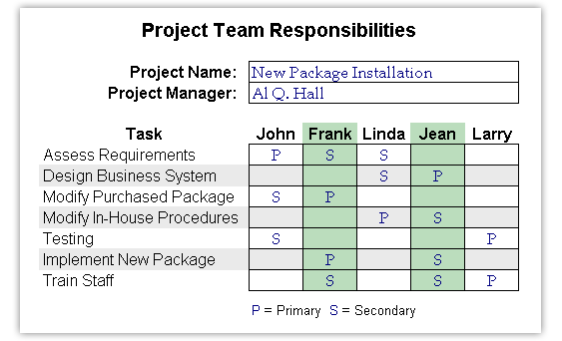

13. Approval

The signatures below indicate their approval of the contents of this document.

Project Role | Name | Signature | Date

